project

August 3, 2024

[1]:

**Billion-Dollar Dreams: India’s Startup Saga**

**Nirmal Janapaneedi**

In the heart of the world’s fastest-growing major economy, a revolution is unfolding. India’s startup ecosystem has become a crucible of innovation, ambition, and unprecedented growth. This project delves into the stories of Indian startups that have achieved remarkable feet. From the bustling streets of Bengaluru to the tech hubs of Noida, we’ll explore how these companies have turned audacious ideas into billion-dollar realities. Through data-driven analysis, we aim to uncover the patterns, challenges, and triumphs that define India’s startup saga, offering insights into the factors that propel young companies from msimple beginnings to the forefront of the global business stage.

# 1. Data Preparation and Setup

## 1.1 Importing Libraries

*# Importing necessary libraries*

**import pandas as pd import numpy as np**

**import matplotlib.pyplot as plt import seaborn as sns**

print("Libraries imported successfully!")

[2]:

Libraries imported successfully!

## 1.2 Loading the Dataset

*# Load the dataset*

df = pd.read_excel('Project Data.xlsx')

print("Dataset imported successfully!")

Dataset imported successfully!

[3]:

## 1.3 Initial Data Exploration

Now, we will perform a preliminary exploration of the dataset to understand its structure and contents. We will check for missing values, data types, and basic statistics.

*# Check the data types and non-null counts*

df.info()

*# Display starting data values*

df.head()

<class 'pandas.core.frame.DataFrame'> RangeIndex: 126 entries, 0 to 125 Data columns (total 11 columns):

# Column Non-Null Count Dtype

|  |  |  |  |  |  |
| --- | --- | --- | --- | --- | --- |
| 0 Name |  | 126 | non-null |  | object |
| 1 State |  | 126 | non-null |  | object |
| 2 City |  | 126 | non-null |  | object |
| 3 Start Year |  | 126 | non-null |  | int64 |
| 4 Founder(s) |  | 126 | non-null |  | object |
| 5 Industry |  | 126 | non-null |  | object |
| 6 Number of Employees |  | 126 | non-null |  | object |
| 7 Funding(in $) |  | 126 | non-null |  | object |
| 8 Funding Rounds |  | 126 | non-null |  | object |
| 9 Number of Investors |  | 126 | non-null |  | object |
| 10 Market Valuation(in | $) | 126 | non-null |  | object |

dtypes: int64(1), object(10) memory usage: 11.0+ KB

|  |  |  |  |  |  |  |
| --- | --- | --- | --- | --- | --- | --- |
| [3]: |  | Name | State | City | Start Year | \ |
|  | 0 | Urban Company | Haryana | Gurgaon | 2014 |  |
|  | 1 | Classplus | Uttar Pradesh | Noida | 2018 |  |
|  | 2 | Paytm | Uttar Pradesh | Noida | 2010 |  |
|  | 3 | Apna | Maharashtra | Mumbai | 2019 |  |
|  | 4 | Razorpay | Karnataka | Bengaluru | 2014 |  |

Founder(s) Industry \

1. Abhiraj Singh Bhal, Raghav Chandra, Varun Khaitan Service
2. Bhaswat Agarwal, Bikash Dash, Mukul Rustagi, N… Education
3. Akshay Khanna, Vijay Shekhar Sharma Finance
4. Nirmit Parikh Human Resource
5. Harshil Mathur, Shashank Kumar Finance

Number of Employees Funding(in $) Funding Rounds Number of Investors \

|  |  |  |  |  |
| --- | --- | --- | --- | --- |
| 0 | 1001-5000 | 445920356 | 12 | 16 |
| 1 | 101-250 | 89506451 | 10 | 20 |
| 2 | 25000-30000 | 32448851 | 4 | 4 |

|  |  |  |  |
| --- | --- | --- | --- |
|  | 3 101-250 93450000 | 4 | 6 |
| 4 1001-5000 366600000 | 7 | 29 |
| Market Valuation(in $) 0 2180000000 |  |  |
| 1 626000000 |  |  |
| 2 2500000000 |  |  |
| 3 1100000000 |  |  |
| 4 7500000000 |  |  |
| [4]: | *# Display trailing data values* |  |  |
|  | df.tail() | | |

|  |  |  |  |  |  |  |
| --- | --- | --- | --- | --- | --- | --- |
| [4]: |  | Name | State | City Start | Year | \ |
|  | 121 | Astrogate Labs | Karnataka | Bengaluru | 2019 |  |
|  | 122 | Vesta Space | Maharashtra | Pune | 2020 |  |
|  | 123 | Digantara | Karnataka | Bengaluru | 2018 |  |
|  | 124 | SatSure | Karnataka | Bengaluru | 2016 |  |
|  | 125 | Rockinjiny | Tamil Nadu | Chennai | 2020 |  |

|  |  |  |  |  |  |
| --- | --- | --- | --- | --- | --- |
| Founder(s) | | | Industry | Number of Employees | \ |
| 121 Nitish Singh, Neha Singh | | | Communication | 51-100 |  |
| 122 Kranthi Chand, Rajeev Sharma | | | Space | 51-100 |  |
| 123 Anirudh Sharma, Rahul Rawat | | | Space | 51-100 |  |
| 124 Prateep Basu, Rashmit Singh Sukhmani | | | Space | 101-250 |  |
| 125 Vinay Kumar, Sai Praneeth | | | Space | 51-100 |  |
| Funding(in $) Funding Rounds Number of | | | Investors Market Valuation(in $) | |  |
| 121 | 1000000 | 2 | 4 | 10000000 | |
| 122 | 500000 | 1 | 2 | 5000000 | |
| 123 | 1200000 | 3 | 5 | 8000000 | |
| 124 | 6000000 | 4 | 6 | 50000000 | |
| 125 | 500000 | 1 | 2 | 3000000 | |
|  | **2. Data Cleaning** |  |  |  | |

[5]:

Next we will focus on Data Cleaning. This step ensures that the data is in a suitable format for analysis and helps to improve the quality and accuracy of our results.

## 2.1 Checking for Missing Values

*# Check for missing values*

missing_values = df.isnull().sum()

*# Display the number of missing values for each column*

missing_values

[5]: Name 0

State 0

City 0

Start Year 0

Founder(s) 0

Industry 0

Number of Employees 0

Funding(in $) 0

Funding Rounds 0

Number of Investors 0

Market Valuation(in $) 0

dtype: int64

Depending on the results, we handle missing values. We might choose to fill them with a default value, the mean/median, or remove rows/columns with missing data.

## 2.2 Data Type Conversion

Ensure that columns are in the correct format

[6]: *# Convert 'Funding(in $)' to numeric, invalid parsing will be set as NaN*

df['Funding(in $)'] = pd.to_numeric(df['Funding(in $)'].replace({',': ''},␣

↪regex=**True**), errors='coerce')

*# Convert 'Market Valuation(in $)' to numeric, invalid parsing will be set as*␣

↪*NaN*

df['Market Valuation(in $)'] = pd.to_numeric(df['Market Valuation(in $)'].

↪replace({',': ''}, regex=**True**), errors='coerce')

*# Check for NaN values in 'Funding(in $)' and 'Market Valuation(in $)'*

nan_funding = df[df['Funding(in $)'].isna()] nan_valuation = df[df['Market Valuation(in $)'].isna()]

*# Display NaN values*

print("Rows with NaN values in Funding(in $):") print(nan_funding)

print("**\n**Rows with NaN values in Market Valuation(in $):") print(nan_valuation)

*# Drop rows with NaN values in 'Funding(in $)' or 'Market Valuation(in $)'*

df.dropna(subset=['Funding(in $)', 'Market Valuation(in $)'], inplace=**True**)

*# Verify data types*

df.dtypes

*# Display the first few rows to ensure correct conversion*

df.head()

Rows with NaN values in Funding(in $):

Name State City Start Year Founder(s) \

89 StartupHR Software Maharashtra Mumbai 2021 Waqar Azmi

Industry Number of Employees Funding(in $) Funding Rounds \

89 Internet Software 101-250 NaN Bootstrapped

Number of Investors Market Valuation(in $)

89 - NaN

Rows with NaN values in Market Valuation(in $):

Name State City Start Year \

8 BigBasket Karnataka Bengaluru 2011

89 StartupHR Software Maharashtra Mumbai 2021

|  |  |  |  |  |  |
| --- | --- | --- | --- | --- | --- |
| 8 | Abhinay Choudhari, | Founder(s) Hari Menon, Vipul Parekh, V… | | Industry E-Commerce | \ |
| 89 |  | Waqar Azmi | | Internet Software |  |
|  | Number of Employees | Funding(in $) Funding Rounds Number of Investors | | | \ |
| 8 | 5001-10000 | 1.119863e+09 | 17 | 17 | |
| 89 | 101-250 | NaN | Bootstrapped | - | |

Market Valuation(in $)

8 NaN

89 NaN

[6]: Name State City Start Year \

|  |  |  |  |
| --- | --- | --- | --- |
| 0 Urban Company | Haryana | Gurgaon | 2014 |
| 1 Classplus | Uttar Pradesh | Noida | 2018 |
| 2 Paytm | Uttar Pradesh | Noida | 2010 |
| 3 Apna | Maharashtra | Mumbai | 2019 |
| 4 Razorpay | Karnataka | Bengaluru | 2014 |

Founder(s) Industry \

1. Abhiraj Singh Bhal, Raghav Chandra, Varun Khaitan Service
2. Bhaswat Agarwal, Bikash Dash, Mukul Rustagi, N… Education
3. Akshay Khanna, Vijay Shekhar Sharma Finance
4. Nirmit Parikh Human Resource
5. Harshil Mathur, Shashank Kumar Finance

Number of Employees Funding(in $) Funding Rounds Number of Investors \

|  |  |  |  |  |
| --- | --- | --- | --- | --- |
| 0 | 1001-5000 | 445920356.0 | 12 | 16 |
| 1 | 101-250 | 89506451.0 | 10 | 20 |
| 2 | 25000-30000 | 32448851.0 | 4 | 4 |
| 3 | 101-250 | 93450000.0 | 4 | 6 |
| 4 | 1001-5000 | 366600000.0 | 7 | 29 |

Market Valuation(in $) 0 2.180000e+09

1 6.260000e+08

2 2.500000e+09

3 1.100000e+09

4 7.500000e+09

[7]:

# 3. Data Analysis & Interpretation

In this part, we will try to understand valuable insights from the data by asking numerous ques- tions. Finding solutions for those questions with the help of visualizations and data interpretation techniques, thereby, we will be able to understand our data set and analyze effectively.

## 3.1 Distribution of Startups across different states and cities in India

Barplot of startups by state

*# Count startups by state*

state_counts = df['State'].value_counts()

*# Count startups by city*

city_counts = df['City'].value_counts()

*# Bar plot of startups by state*

plt.figure(figsize=(12, 8)) sns.barplot(x=state_counts.index, y=state_counts.values) plt.title('Number of Startups by State') plt.xlabel('State')

plt.ylabel('Number of Startups') plt.xticks(rotation=45) plt.show()

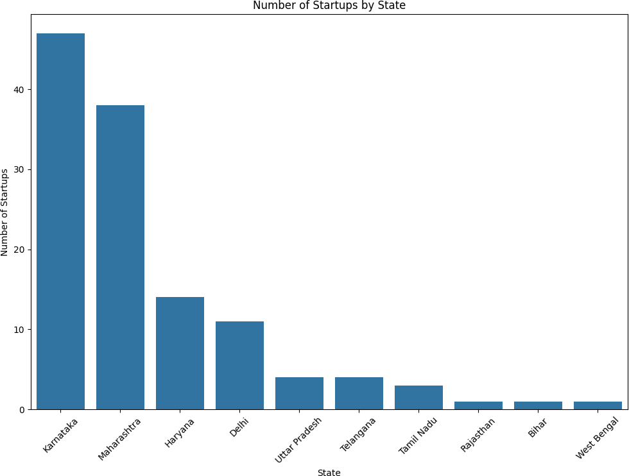

Bar plot of startups by city (top 5 cities)

[8]:

*# Bar plot of startups by city (top 5 cities)* top_cities = city_counts.head(5) plt.figure(figsize=(12, 8)) sns.barplot(x=top_cities.index, y=top_cities.values) plt.title('Number of Startups by City (Top 10)') plt.xlabel('City')

plt.ylabel('Number of Startups') plt.xticks(rotation=45) plt.show()

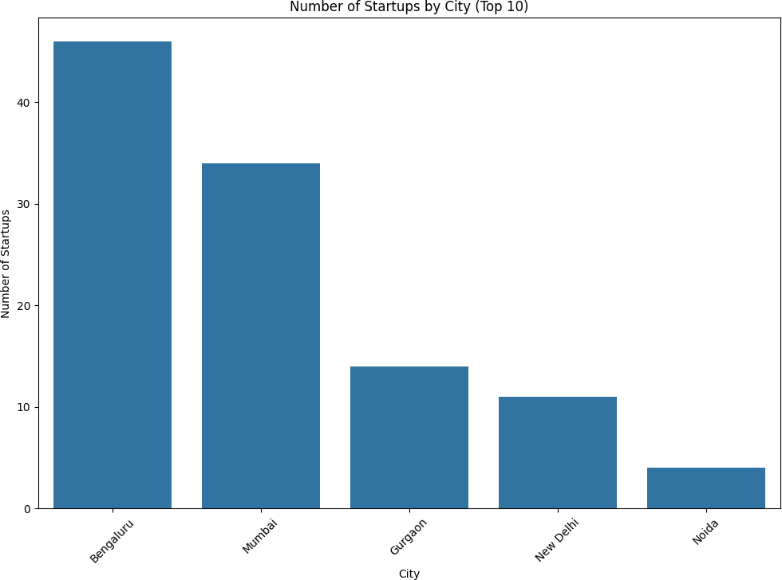

[9]:

Let’s compare startups in South India and North India

States considered as a part of South India - [Karnataka, Andhra Pradesh, Telangana, Kerala, Tamil Nadu, Maharashtra]

*# Define the states in South India*

south_india_states = ['Karnataka', 'Andhra Pradesh', 'Telangana', 'Kerala',␣

↪'Tamil Nadu', 'Maharashtra']

*# Create a new column 'Region' to categorize as 'South India' or 'North India'*

df['Region'] = df['State'].apply(**lambda** x: 'South India' **if** x **in**␣

↪south_india_states **else** 'North India')

*# Count startups by region*

region_counts = df['Region'].value_counts()

*# Plot the number of startups in North India vs. South India with counts*

plt.figure(figsize=(8, 6))

ax = sns.barplot(x=region_counts.index, y=region_counts.values) plt.title('Number of Startups in North India vs. South India') plt.xlabel('Region')

plt.ylabel('Number of Startups')

*## Add counts on top of the bars*

**for** index, value **in** enumerate(region_counts.values):

ax.text(index, value + 0.5, str(value), ha='center', va='bottom')

plt.show()

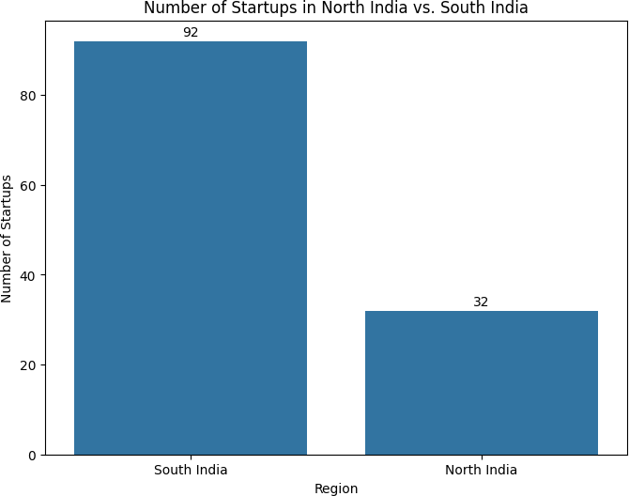

Let’s analyze deeper to understand the state-wise south indian startups.

[10]:

*# Filter the dataset for South Indian states*

south_india_df = df[df['Region'] == 'South India']

*# Count startups by state in South India*

south_india_state_counts = south_india_df['State'].value_counts()

*# Plot the number of startups by state in South India*

plt.figure(figsize=(10, 6))

ax = sns.barplot(x=south_india_state_counts.index, y=south_india_state_counts.

↪values)

plt.title('Number of Startups by State in South India') plt.xlabel('State')

plt.ylabel('Number of Startups')

*# Add counts on top of the bars*

**for** index, value **in** enumerate(south_india_state_counts.values): ax.text(index, value + 0.5, str(value), ha='center', va='bottom')

plt.show()

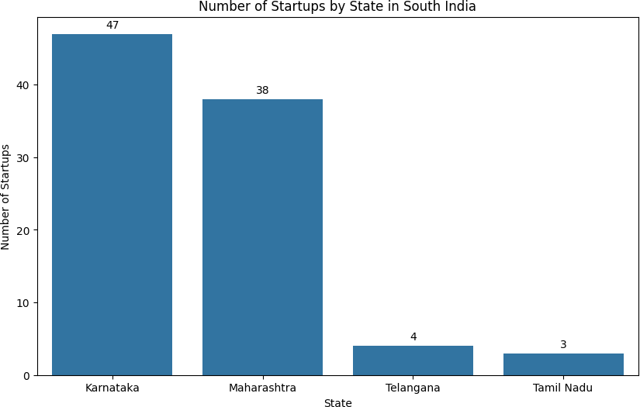

[11]:

# 3.2 Industrial patterns in the startup ecosystem in India

Barplot of most common industries in which startups are rising in India.

*# Count the number of startups in each industry*

industry_counts = df['Industry'].value_counts().head(10)

*# Plotting the bar chart*

plt.figure(figsize=(12, 6))

sns.barplot(x=industry_counts.values, y=industry_counts.index,orient='h') plt.title('Top 10 Most Common Industries in India')

plt.xlabel('Number of Startups')

plt.ylabel('Industry')

*# Add the counts next to the bars*

**for** index, value **in** enumerate(industry_counts.values): plt.text(value, index, str(value), va='center')

plt.show()

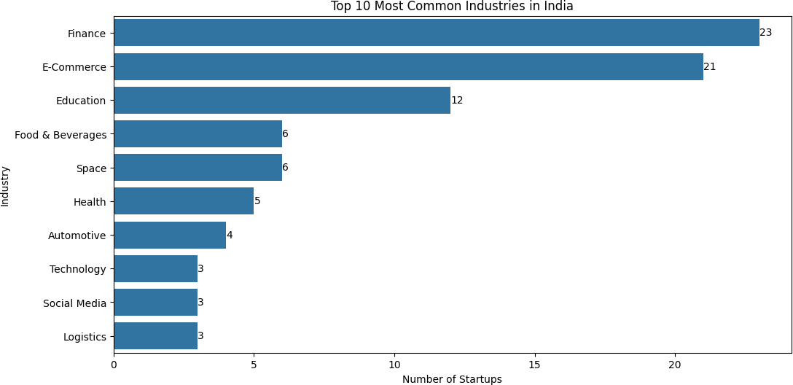

Let’s find out how the top south indian state (in terms of startups) has its industrial distribution.

[12]:

*# Determine the top South Indian state by number of startups*

top_south_india_state = south_india_df['State'].value_counts().idxmax()

*# Filter data for the top South Indian state*

top_state_df = south_india_df[south_india_df['State'] == top_south_india_state]

*# Count startups by industry within this state*

top_state_industry_counts = top_state_df['Industry'].value_counts()

*# Plot the number of startups by industry for the top South Indian state*

plt.figure(figsize=(12, 8))

ax = sns.barplot(x=top_state_industry_counts.values,␣

↪y=top_state_industry_counts.index, orient='h')

plt.title(f'Number of Startups by Industry in **{**top_south_india_state**}**') plt.xlabel('Number of Startups')

plt.ylabel('Industry') plt.show()

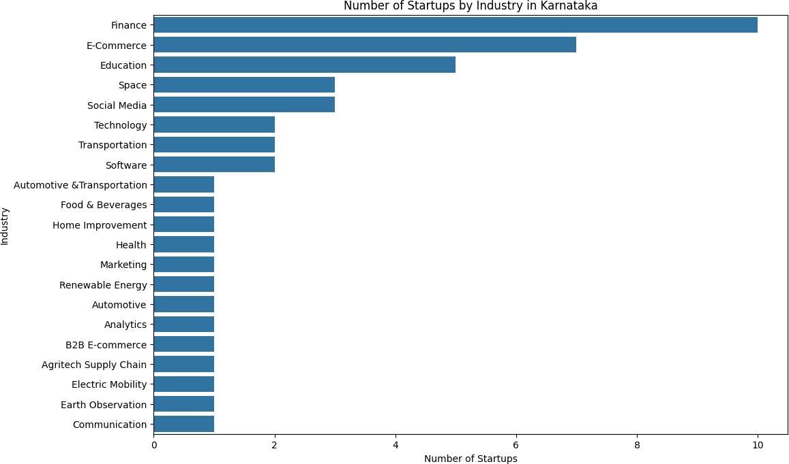

Similarly,let’s find out how the top north indian state (in terms of startups) has its industrial distribution.

[13]: *# Filter the dataset for North Indian states*

north_india_df = df[df['Region'] == 'North India']

*# Count startups by state in North India*

north_india_state_counts = north_india_df['State'].value_counts()

*# Determine the top North Indian state by number of startups*

top_north_india_state = north_india_df['State'].value_counts().idxmax()

*# Filter data for the top North Indian state*

top_state_df = north_india_df[north_india_df['State'] == top_north_india_state]

*# Count startups by industry within this state*

top_state_industry_counts = top_state_df['Industry'].value_counts()

*# Plot the number of startups by industry for the top South Indian state*

plt.figure(figsize=(12, 8))

ax = sns.barplot(x=top_state_industry_counts.values,␣

↪y=top_state_industry_counts.index, orient='h')

plt.title(f'Number of Startups by Industry in **{**top_north_india_state**}**') plt.xlabel('Number of Startups')

plt.ylabel('Industry') plt.show()

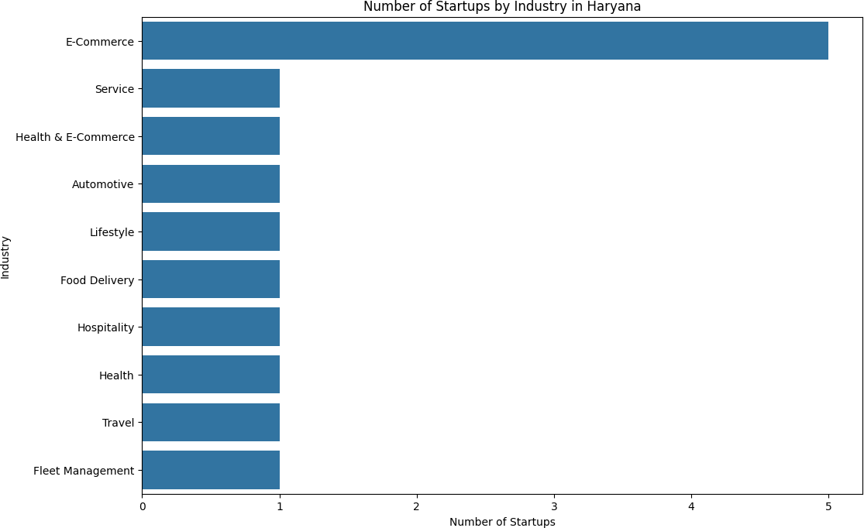

Which industries in the indian startup ecosystem are receiving the most funding?

[14]:

*# Define the datasets*

top_5_industries = df.groupby('Industry')['Funding(in $)'].sum().

↪sort_values(ascending=**False**).head(5)

least_5_industries = df.groupby('Industry')['Funding(in $)'].sum().

↪sort_values(ascending=**False**).tail(5)

*## Plotting Top 5 Industries (hue and palette)*

plt.figure(figsize=(12, 6))

ax1 = sns.barplot(x=top_5_industries.values, y=top_5_industries.index,␣

↪orient='h')

plt.title('Top 5 Industries by Total Funding') plt.xlabel('Total Funding (in $)') plt.ylabel('Industry')

*# Add funding amounts next to the bars*

**for** index, value **in** enumerate(top_5_industries.values): ax1.text(value, index, f'$**{**value**:**,.0f**}**', va='center')

plt.show()

*## Plotting Least 5 Industries (hue and palette)*

plt.figure(figsize=(12, 6))

ax2 = sns.barplot(x=least_5_industries.values, y=least_5_industries.index,␣

↪orient='h')

plt.title('Least 5 Industries by Total Funding') plt.xlabel('Total Funding (in $)') plt.ylabel('Industry')

*# Add funding amounts next to the bars*

**for** index, value **in** enumerate(least_5_industries.values): ax2.text(value, index, f'$**{**value**:**,.0f**}**', va='center')

plt.show()

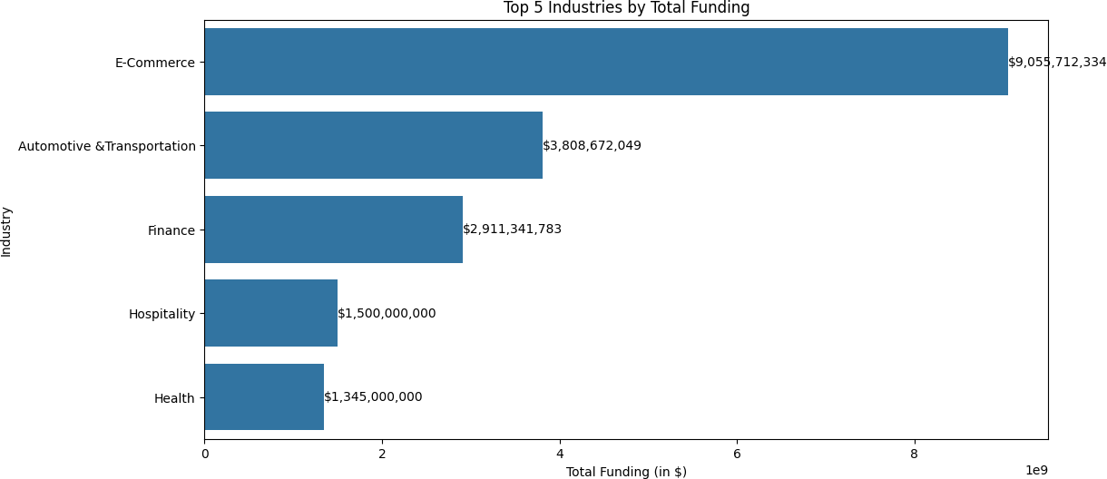

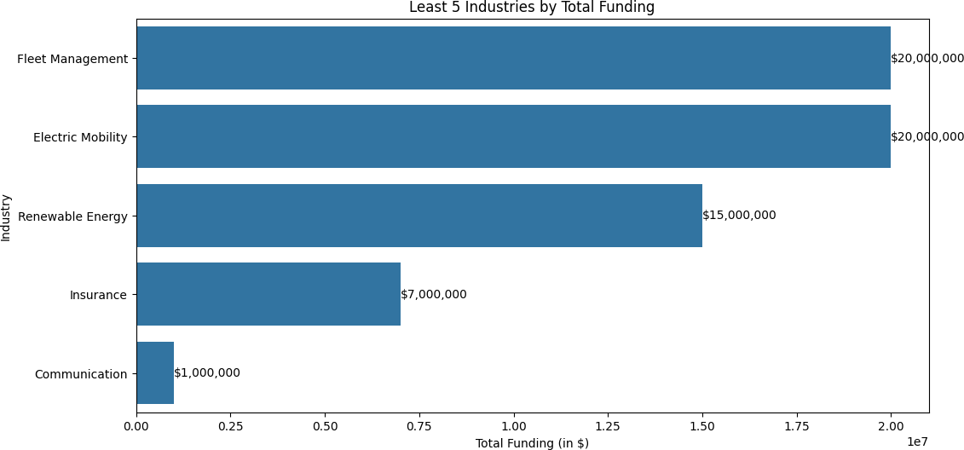

How about we find out which industries have billion-dollar or more market valued companies.

[15]:

*# Convert Market Valuation to numeric if it's not already*

df['Market Valuation(in $)'] = pd.to_numeric(df['Market Valuation(in $)'].

↪replace({',': ''}, regex=**True**), errors='coerce')

*# Filter for companies with billion-dollar or more valuation*

billion_dollar_companies = df[df['Market Valuation(in $)'] >= 1e9]

*# Count the number of billion-dollar companies in each industry*

industry_counts = billion_dollar_companies['Industry'].value_counts()

*# Create a bar plot*

plt.figure(figsize=(12, 6))

sns.barplot(x=industry_counts.values, y=industry_counts.index, orient='h') plt.title('Industries with Billion-Dollar or More Valued Companies') plt.xlabel('Number of Companies')

plt.ylabel('Industry')

*# Add count labels to the end of each bar*

**for** i, v **in** enumerate(industry_counts.values): plt.text(v, i, str(v), va='center')

plt.tight_layout() plt.show()

*# Print the industries and their counts*

print("Industries with billion-dollar or more valued companies:")

**for** industry, count **in** industry_counts.items(): print(f"**{**industry**}**: **{**count**}**")

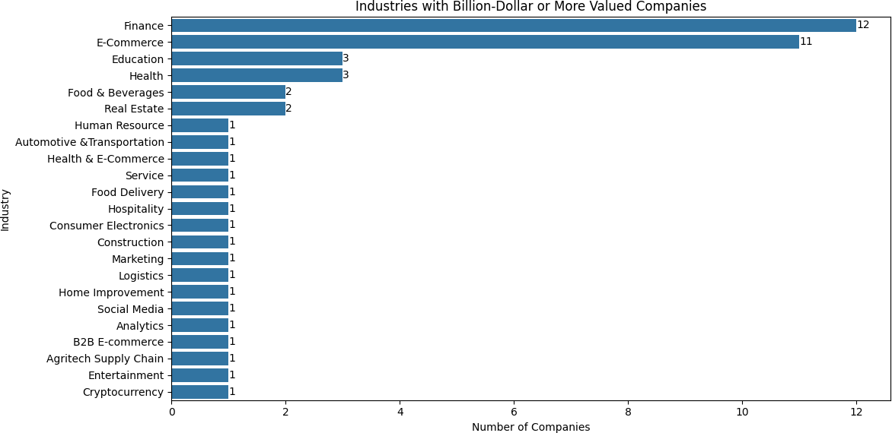

[16]:

Industries with billion-dollar or more valued companies: Finance: 12

E-Commerce: 11

Education: 3

Health: 3

Food & Beverages: 2 Real Estate: 2

Human Resource: 1

Automotive &Transportation: 1 Health & E-Commerce: 1 Service: 1

Food Delivery: 1

Hospitality: 1

Consumer Electronics: 1

Construction: 1

Marketing: 1

Logistics: 1

Home Improvement: 1

Social Media: 1

Analytics: 1

B2B E-commerce: 1 Agritech Supply Chain: 1 Entertainment: 1

Cryptocurrency: 1

# 3.3 Analysis of Startup Success Metrics

* + 1. Which startups or industries have the highest market valuation?

*# Sort startups by Market Valuation and select the top 10*

top_startups_by_valuation = df.sort_values(by='Market Valuation(in $)',␣

↪ascending=**False**).head(15)

*# Plotting the top startups by market valuation*

plt.figure(figsize=(12, 6))

ax1 = sns.barplot(x=top_startups_by_valuation['Market Valuation(in $)'],␣

↪y=top_startups_by_valuation['Name'],orient='h')

plt.title('Top 15 Startups by Market Valuation') plt.xlabel('Market Valuation (in $)') plt.ylabel('Startup')

*# Add valuation amounts next to the bars*

**for** index, value **in** enumerate(top_startups_by_valuation['Market Valuation(in␣

↪$)']):

ax1.text(value, index, f'$**{**value**:**,.0f**}**', va='center')

plt.show()

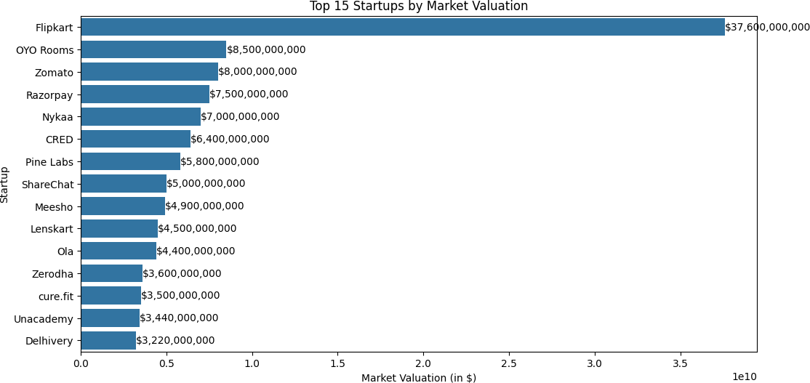

[17]:

*# Calculate total market valuation by industry and select the top 15*

total_valuation_by_industry = df.groupby('Industry')['Market Valuation(in $)'].

↪sum().sort_values(ascending=**False**).head(15)

*# Horizontal Bar Chart*

plt.figure(figsize=(14, 8))

ax2 = sns.barplot(x=total_valuation_by_industry.values,␣

↪y=total_valuation_by_industry.index, orient='h') plt.title('Top 15 Industries by Total Market Valuation') plt.xlabel('Total Market Valuation (in $)') plt.ylabel('Industry')

plt.show()

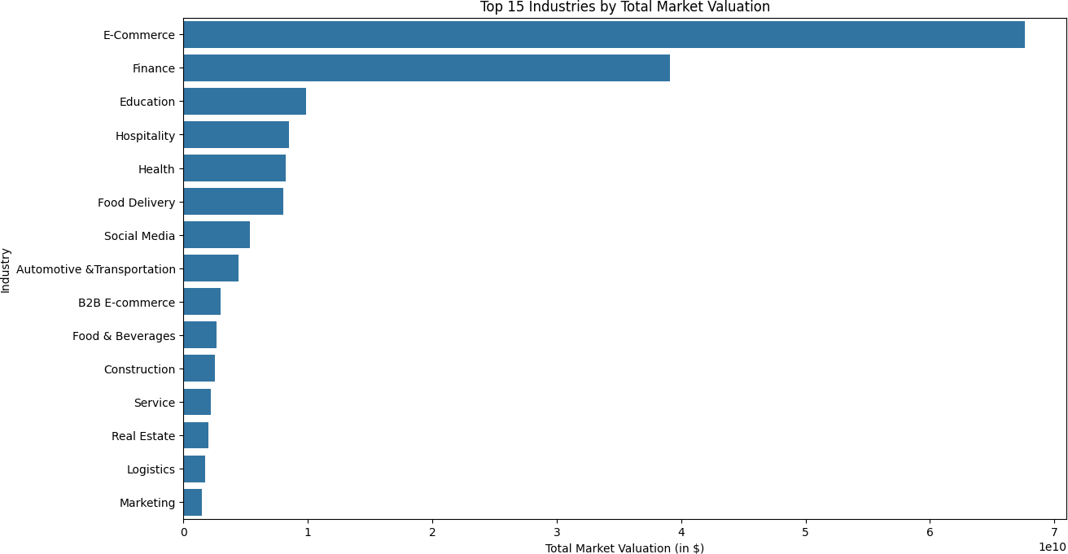

[18]:

*# Replace non-numeric entries in 'Funding Rounds' with NaN and convert to*␣

↪*numeric*

df['Funding Rounds'] = pd.to_numeric(df['Funding Rounds'], errors='coerce')

*# Drop rows with NaN values in 'Funding Rounds'*

df_cleaned = df.dropna(subset=['Funding Rounds'])

*# Scatter Plot: Number of Funding Rounds vs. Total Funding*

plt.figure(figsize=(10, 6))

plt.scatter(df_cleaned['Funding Rounds'], df_cleaned['Funding(in $)'], alpha=0.

↪6, edgecolors='w', s=100)

plt.title('Number of Funding Rounds vs. Total Funding') plt.xlabel('Number of Funding Rounds') plt.ylabel('Total Funding (in $)')

plt.grid(**True**)

plt.colorbar(label='Total Funding (in $)') plt.show()

* + 1. How do the number of funding rounds correlate with the total funding? Scatter Plot: Number of Funding Rounds vs. Total Funding

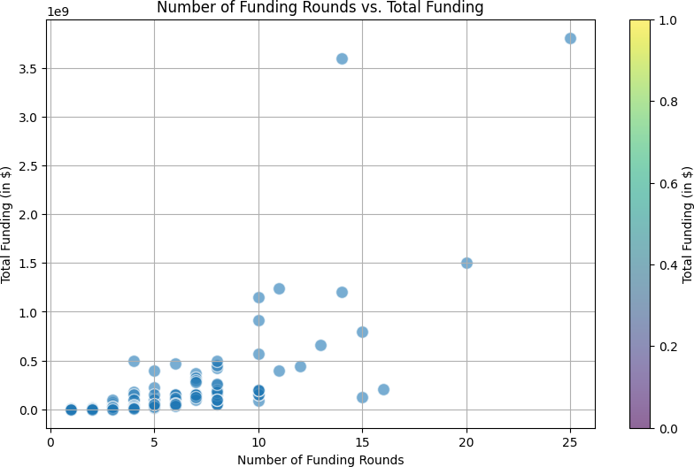

* + 1. Which startups have the highest funding per employee?

[19]:

*## Define a function to calculate the midpoint of the employee range*

**def** calculate_employee_midpoint(employee_range):

**try**:

**if** '+' **in** employee_range:

lower = int(employee_range.replace('+', '').split('-')[0])

**return** lower

lower, upper = map(int, employee_range.split('-'))

**return** (lower + upper) / 2

**except ValueError**: **return** np.nan

*## Calculate the midpoint of the employee range*

df['Employee Midpoint'] = df['Number of Employees'].

↪apply(calculate_employee_midpoint)

*## Calculate funding per employee*

df['Funding per Employee'] = df['Funding(in $)'] / df['Employee Midpoint']

*## Drop rows with NaN values in 'Funding per Employee'*

df_funding_per_employee = df.dropna(subset=['Funding per Employee'])

*## Sort by Funding per Employee and select the top entries*

top_funding_per_employee = df_funding_per_employee.sort_values(by='Funding per␣

↪Employee', ascending=**False**).head(10)

*# Bar Chart for Top Startups by Funding per Employee* plt.figure(figsize=(14, 8)) sns.barplot(x=top_funding_per_employee['Funding per Employee'],␣

↪y=top_funding_per_employee['Name'], orient='h')

plt.title('Top 10 Startups by Funding per Employee') plt.xlabel('Funding per Employee (in $)') plt.ylabel('Startup')

*# Add funding per employee amounts next to the bars*

**for** index, value **in** enumerate(top_funding_per_employee['Funding per Employee']): plt.text(value, index, f'$**{**value**:**,.0f**}**', va='center')

plt.show()

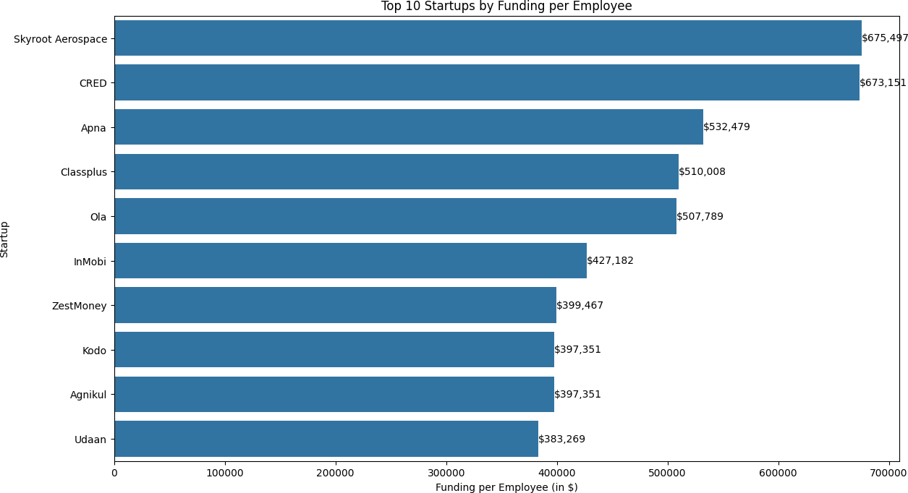

[20]:

*# Filter companies with a market valuation over a billion dollars*

billion_valued_companies = df[df['Market Valuation(in $)'] > 1_000_000_000]

*# Extract the relevant data: company name and employee midpoint*

company_employee_data = billion_valued_companies[['Name', 'Employee Midpoint']].

↪dropna()

* + 1. What do can we understand about the average number of employees for companies that are valued over a billion?

*# Plotting the bar chart for each company* plt.figure(figsize=(14, 8)) sns.barplot(x=company_employee_data['Employee Midpoint'],␣

↪y=company_employee_data['Name'], orient='h')

plt.title('Average Number of Employees for Companies Valued Over $1 Billion') plt.xlabel('Average Number of Employees')

plt.ylabel('Company')

*# Add the average employee numbers next to the bars*

**for** index, value **in** enumerate(company_employee_data['Employee Midpoint']): plt.text(value, index, f'**{**value**:**.0f**}**', va='center')

plt.show()

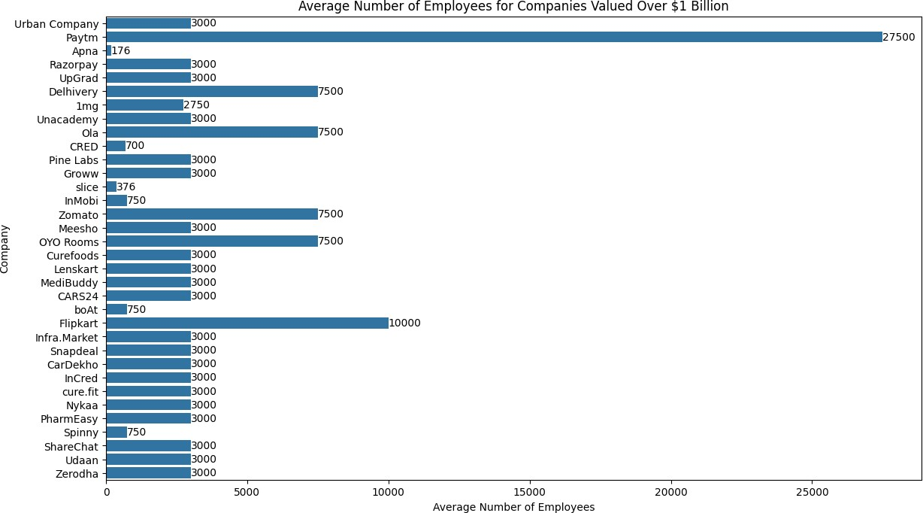

[21]:

*# Calculate the average number of employees (midpoint of the range) for these*␣

↪*companies*

average_employees = billion_valued_companies['Employee Midpoint'].mean()

*# Plotting the bar chart*

plt.figure(figsize=(8, 6))

plt.bar(['Companies Valued Over $1 Billion'], [average_employees], color='teal') plt.title('Average Number of Employees for Companies Valued Over $1 Billion') plt.ylabel('Average Number of Employees')

*# Add the average number next to the bar*

plt.text(0, average_employees, f'**{**average_employees**:**.0f**}**', ha='center',␣

↪va='bottom')

plt.show()

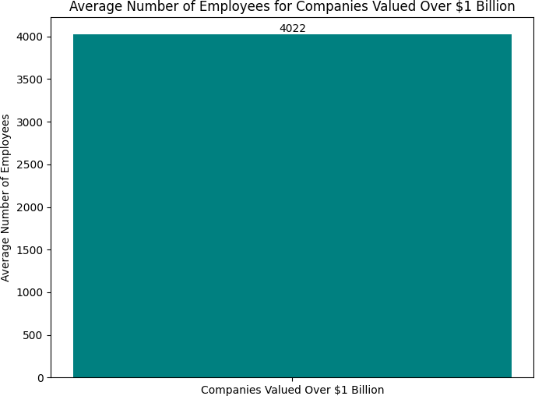

* + 1. What is the number of founders for which their companies are valued over a billion?

[22]:

*# Create a function to count the number of founders*

**def** count_founders(founders_str):

**return** len(founders_str.split(','))

*# Apply the function to create a new column*

df['Number of Founders'] = df['Founder(s)'].apply(count_founders)

*# Create a binary column for billion-dollar valuation*

df['Billion Dollar Valuation'] = df['Market Valuation(in $)'] >= 1e9

*# Calculate the average number of founders for billion-dollar companies and*␣

↪*others*

avg_founders_billion = df[df['Billion Dollar Valuation']]['Number of Founders'].

↪mean()

avg_founders_others = df[~df['Billion Dollar Valuation']]['Number of Founders'].

↪mean()

*# Create a scatter plot*

plt.figure(figsize=(12, 6))

sns.scatterplot(x='Number of Founders', y='Market Valuation(in $)', data=df) plt.title('Number of Founders vs Market Valuation')

plt.xlabel('Number of Founders') plt.ylabel('Market Valuation (in $)') plt.yscale('log')

plt.show()

*# Print average number of founders*

print(f"Average number of founders for billion-dollar companies:␣

↪**{**avg_founders_billion**:**.2f**}**")

print(f"Average number of founders for other companies: **{**avg_founders_others**:**.

↪2f**}**")

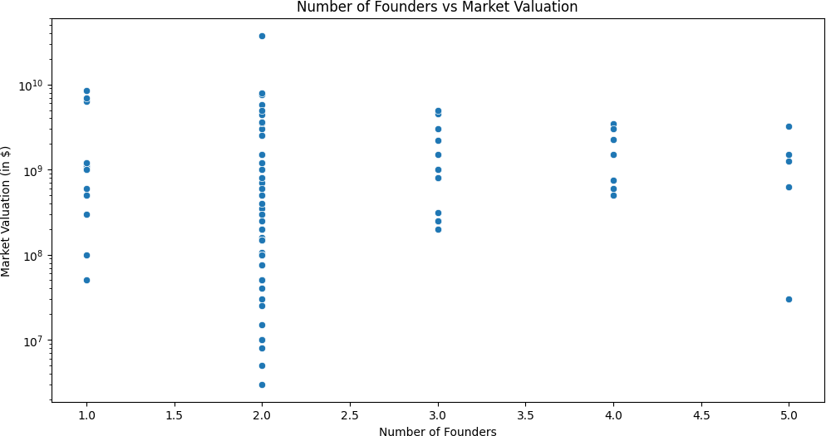

[23]:

Average number of founders for billion-dollar companies: 2.30 Average number of founders for other companies: 2.16

# 3.4 Key Takeaways and Future Outlook

Dominant Trends in the Indian Startup Ecosystem

**from wordcloud import** WordCloud

*# Generate a word cloud for industries*

wordcloud = WordCloud(width=800, height=400, background_color='white').

↪generate(' '.join(df['Industry']))

*# Plot the word cloud*

plt.figure(figsize=(10, 5)) plt.imshow(wordcloud, interpolation='bilinear') plt.axis('off')

plt.title('Word Cloud of Startup Industries') plt.show()

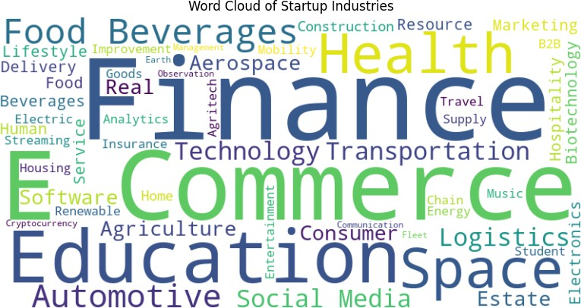

Growth of startup eco-system in India

[24]:

*# Count the number of startups founded each year*

startups_per_year = df['Start Year'].value_counts().sort_index()

*# Create the line plot*

plt.figure(figsize=(12, 6))

sns.lineplot(x=startups_per_year.index, y=startups_per_year.values, marker='o') plt.title('Growth of Startup Ecosystem in India', fontsize=16) plt.xlabel('Year', fontsize=12)

plt.ylabel('Number of Startups Founded', fontsize=12)

*# Add value labels on the data points*

**for** x, y **in** zip(startups_per_year.index, startups_per_year.values): plt.text(x, y, str(y), ha='center', va='bottom')

*# Adjust layout to prevent cutting off labels*

plt.tight_layout()

plt.show()

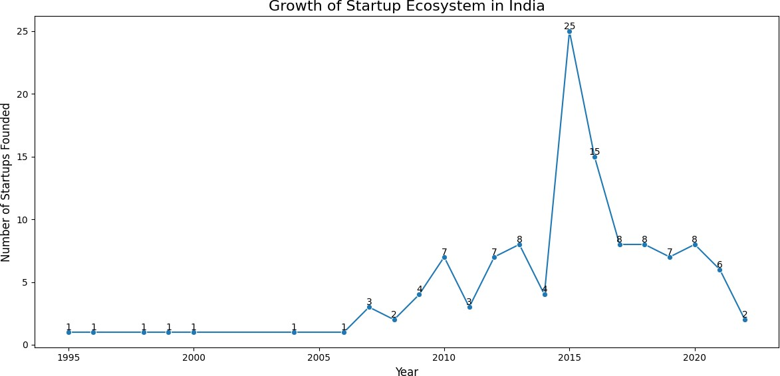

# 4.Conclusion

This project provides a comprehensive analysis of India’s growing startup ecosystem, leveraging data-driven insights to uncover patterns, challenges, and opportunities. Through our exploration, we’ve gained valuable insights into various aspects of the Indian startup landscape:

## Key Findings

* + - 1. **Geographical Distribution**: We identified the states and cities that are hotbeds for startup activity, with a notable concentration in certain regions.
      2. **Industry Trends**: Our analysis revealed the most prevalent industries in the Indian startup ecosystem, highlighting sectors that are attracting significant entrepreneurial interest.
      3. **Funding Patterns**: We examined the distribution of funding across different startups and industries, shedding light on which sectors are attracting the most investment.
      4. **Unicorn Analysis**: Our investigation into billion-dollar valuations provided insights into the characteristics of highly successful startups.
      5. **Startup Growth**: The year-wise analysis of startup formation illustrated the rapid growth and evolution of India’s startup ecosystem over time.

## Implications

* The concentration of startups in certain regions suggests both opportunities for growth in less saturated areas and potential for resource competition in startup hubs.
* The diversity of industries represented in the ecosystem indicates a broad base for innovation and economic growth.
* Funding patterns reveal sectors that investors find promising, which could guide future en- trepreneurs and policymakers.
* The analysis of billion-dollar startups provides valuable insights into the factors that con- tribute to extraordinary success in the Indian market.

## Future Directions

While this analysis provides a solid foundation for understanding India’s startup ecosystem, there are several avenues for further research:

* + - 1. Deeper dive into sector-specific trends and challenges.
      2. Analysis of startup survival rates and factors contributing to longevity.
      3. Investigation of the impact of government policies on startup growth and success.
      4. Comparative analysis with startup ecosystems in other emerging markets.

By continuing to analyze and understand these trends, we can better support the growth and success of India’s vibrant startup ecosystem, fostering innovation and economic development.